Study the effect of flower waste, vegetable waste with the combination of compost on plant growth
Neha Arya and H C Katariya
Department of Chemistry, Govt. Gitanjali Girls College, Bhopal, India
Email: arya.neha44@gmail.com
Abstract:
Soil organisms are essential for nutrient cycling and organic matter turn over, thereby functioning as key determinants of soil fertility and nutrient uptake by plants. The temple wastes consist of vegetable material, most of which are biodegradable and contain elements required for growth of plant and microorganisms. Average plant height ranges from 13 cm to 18 cm in all various treatments. The plant height was significantly different among various vermicompost treatments. The maximum and minimum plant height of 18 and 13 cm was obtained in T3 and T-1, respectively. The root length and shoot length also significantly differing in all treatments. Average fruit weight ranges from 69.31 to 150.7 gm (4.7). Present study, demonstrates that the combination of cow dung manure and biofertilizer also contains all nutrients for better growth of plants.
Keywords: Flower waste, vermicompost, cow dung manure, plant growth, tomato etc.
Introduction:
Today in all over the world managing different organic wastes at low capital and operational cost as well as in ecofriendly and energy saving basis has attracted much attention. Like other developing countries, Indian cities and towns also suffer with the environmental costs of solid waste management. The large amount of solid waste and sludge produced by anthropogenic sources is becoming a serious problem. Proper waste management is very crucial and has become the main challenge in many countries (Mujeebunisa et al., 2013).
The number of temples and mosques in India is a puzzle. Imagine the amount of flower being used at these temples and then being sent to water bodies for disposal. Showering flowers is a religious ritual in India. Flowers are a symbol of devotion and reverence. According to many religious beliefs, flowers that are offered during prayers are sacrosanct and cannot be dumped into the garbage once they’ve wilted (Samadhiyaa et al., 2016.). This is one of the reasons why people prefer to discard them in rivers, lakes and other water bodies. But not many of us think about the fertilizers and pesticides that might have been used to grow these flowers, which then mix with the water and pollute it (Mahindrakar, 2018). These materials are wholly biodegradable. The organic nature of these wastes offers various biological management options such as vermicomposting instead of disposal to landfill sites, open dumping or any other environmentally risky waste management alternatives (Jain, 2016).The main objectives of the present study are to develop efficient technology for environmentally safe management of temple solid waste and also to see its effect on plant growth.
Materials & Methods;
The performance of vermicompost, cow dung manure and vegetable/flower waste of temples was investigated on growth and yield of tomato plants. Both plant seeds were planted in 10 cm of diameter pot. An experiment was conducted in Randomized Complete Blocks Design (RCBD) with Three replications and four treatment (T1 = Control, T2 = Vermicompost, and T3 = cow dung manure+ vermicompost+ biofertilizers and T4= vermicmpst+ flower and vegetable waste) at Rapture Biotech Institute, Bhopal during 2017. The seeds sown in the rainy season and both plants were grown in three row plots. All composts were applied to the combination of soil in 50:50. All plants were cultivated in nursery with 50% of actual light intensity. After 15 day of plant cultivation, these plants were harvested for morphological analysis.
3.5 Morphological Characteristic Analysis
An Agronomic characteristics included plant height, number of fruit per plant, individual fruit weight per plant, total fruit weight per plant, fruit size and fruit yield per plant. Data were recorded on 3 competitive plants of each plot was calculated for the entire plot.
Results and Discussion
During the present investigation the effect of different composts viz: vermicompost, cow dung manure and biofertilizer were studied on growth parameters of tomato. The growth characteristics and parameters of the tomato plants and fruits are summarized in Table 1 and Table 2.
Average plant height ranges from 13 cm to 18 cm in all various treatments. The plant height was significantly different among various vermicompost treatments. The maximum and minimum plant height of 18 and 13 cm was obtained in T3 and T-1, respectively (Figure 1). The root length and shoot length also significantly differing in all treatments. Average fruit weight ranges from 69.31 to 150.7 gm (4.7). Vermicompost treated plant of tomato exhibited maximum weight and size of fruits. Present study, demonstrates that the combination of cow dung manure and biofertilizer also contains all nutrients for better growth of plants.
Alidadi et al., (2014) reported that the using the vermicompost and cow manure significantly increased the yield and growth of tomato plants. Similar results were found in the study done by Alwaneen, 2016; Ahirwar and Hussain, 2015; Gill et al., 2018, Gupta, 2016 and Sharma and Agarwal, 2014).
The application of vermicompost to improve the physical properties of soils is a promising technology to meet the requirements of high plant growth and cost-effective recovery. It also increased the length of plant that direct the more surface area for arising of leaf, flower and pod. By using of vermicompost, chlorophyll content also increased as compared to cattle dung treated plant showed more production of wheat and urad (Bhati and Shouche, 2017).

Table 1 Comparative effects of all treatments on growth pattern of tomato plants.
Treatments | Root length (cm) | Shoot length (cm) | Plant Height (cm) | Dry weight (g)
T1 | 5 | 8 | 13 | 2.5
T2 | 7.33 | 11.33 | 17.66 | 4.40
T3 | 6.66 | 13.33 | 18 | 2.9
T4 | 6.66 | 8.66 | 17.66 | 3.1

Table 2 Comparative effects of all treatments on growth pattern of tomato fruits
Treatments | Length of fruits (cm) | Width of fruits (cm) | Average weight (g) | Quantity (Kg)
T1 | 2.75 | 1.8 | 69.13 | 4.25
T2 | 6.9 | 3.65 | 150.7 | 12
T3 | 6.74 | 4.89 | 110 | 9.78
T4 | 5.65 | 4.25 | 89.78 | 8.76

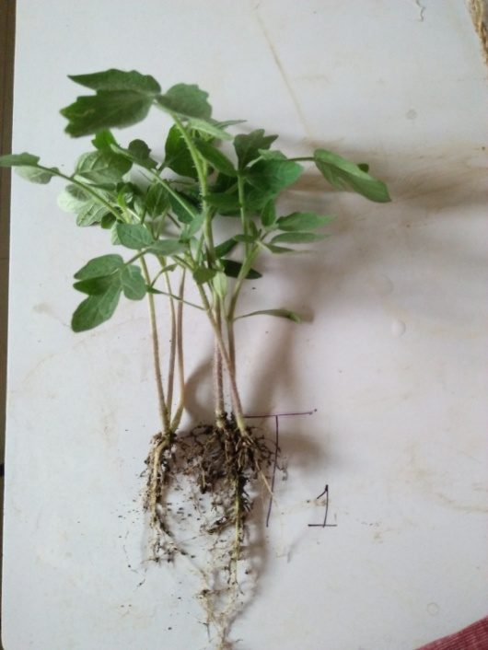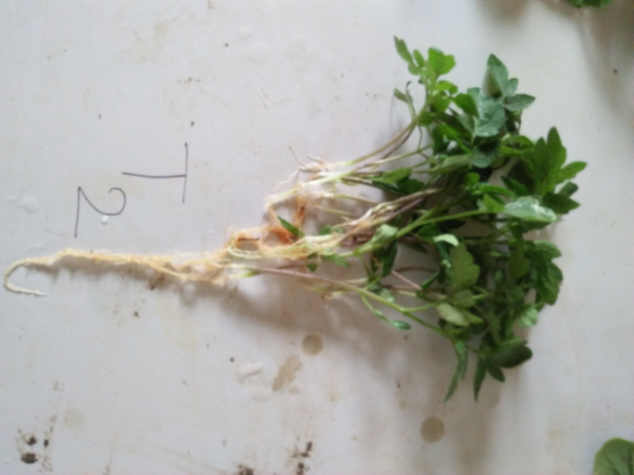
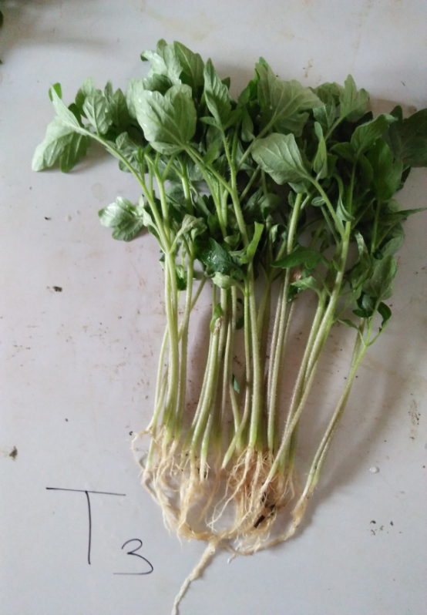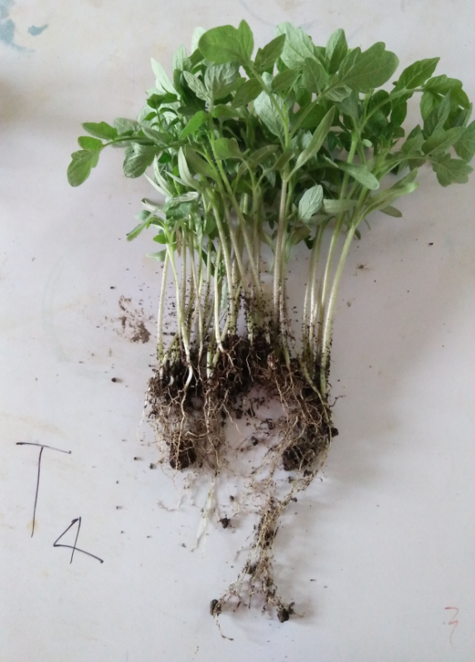
Figure 1 Comparative effects of all compost with control on the growth of tomato plants

Conclusion
The present study concluded that the combination of Vermicompost+ floral waste with cow dung appears to be the most promising high value bio-fertilizer. This is not only increases the plant growth and productivity by nutrient supply but also is cost effective and pollution free. It helped to reduce volume of temple flower waste, but also generate additional revenue. Thus vermicompost technology can be successfully applied in temples as a solid waste management strategy with flower as the major organic waste
References:
Mujeebunisa M, Divya V and Aruna D. Effect of leaf litter, vegetable waste, coffee waste, flower waste and may flower waste added vermicompost on weight gain in Eudrilus eugeniae. Asian Journal of Plant Science and Research, 2013, 3(6):1-4.
Mahindrakar A. Floral Waste Utilization- A Review. Int. J. Pure App. Biosci.. 2018, 6 (2): 325-329.
Jain N. Waste Management of Temple Floral offerings by Vermicomposting and its effect on Soil and Plant Growth. International Journal of Environmental & Agriculture Research, 2016, [Vol-2, Issue-7], 89-94.
Samadhiyaa H, Chauhanb PS, Guptaa RB and Agrawal OP. Comparative Study Of Effect Of Temple Waste Vermicompost And Cattle Dung Vermicompost On The Growth And Development Of Bhindi Plant (Hibiscus esculentus). Oct. Jour. Env. Res., 2017, Vol. 5(2): 112-121.
Alidadi H, Saffari AR, Ketabi D, Peiravi R, Hosseinzadeh A. Comparison Of Vermicompost And Cow Manure Efficiency On The Growth And Yield Of Tomato Plant. Health Scope. 2014; 3(4): E14661.
Alwaneen WS. Effect Of Cow Manure Vermicompost On Some Growth Parameters Of Alfalfa And Vinca rosa Plants. Asian Journal Of Plant Sciences, 2016, 15: 81-85.
Ahirwar CS And Hussain A. Effect Of Vermicompost On Growth, Yield And Quality Of Vegetable Crops. International Journal Of Applied And Pure Science And Agriculture (IJAPSA), 2015, Volume 01, Issue 8, 49-56.
Bhati P, Shouche S. Comparative Study Of Soil Mixed Vermicompost And Cattle Dung On The Growth Parameters Of Triticum astivum (Wheat) And Faciolus mungo (Urad) Plant”. American Research Journal Of Agriculture, 2017, V3, I1; Pp:1-14.
Gill P, Singh D, Kumar TR, Kumar P And Gupta RK. Comparative Effect Of Different Fertilizers On Various Growth Parameters Of Lycopersicum esculantum. Int.J.Curr.Microbiol.App.Sci,2018, 7(1): 56-60.
Gupta AK, Tiwari D, Singh G, Mani M. Comparative Study Of Manure Produced From Wastes. International Journal Of Advance Research, Ideas And Innovations In Technology, 2016, 2(6), 1-6.
Sharma J And Agarwal S. Organic Vs Chemical Nutrition – A Pot Culture Experiment With Tomato, Brinjal And Okra. Pop. Kheti, 2014, 2(3): 81-88.

